

***ASSIGNMENT NO. 04 (SOLUTION)***

**FALL - 2022**

**Q. 1 Time Value of Money**

1. Find a simple interest on Rs. 10,000 for 5 years at 6 percent per annum?
2. Find a simple interest on Rs. 15,000 for 7 years at 8 percent per annum?
3. Find compound amount of Rs. 10,000 in 6 years at 10% per annum?.
4. Find compound amount of Rs. 22,000 in 8 years at 14% per annum?.
5. Find discount amount of Rs. 30,000 in 7 years at 15% per annum?
6. Find discount amount of Rs. 50,000 in 9 years at 13% per annum?
7. Mr. Saleem deposits Rs. 60,000 in a bank at end of each year for 4 years. If the interest rate is 12% compounded annually, what would he receive at the end of 4 years?
8. Mr. Saleem deposits Rs. 60,000 in a bank at start of each year for 4 years. If the interest rate is 12% compounded annually, what would he receive at the end of 4 years?
9. What is the Present Value of an annuity that would pay Rs. 10000 a year for 15 years, assuming an interest rate of 8% discounted annually?.

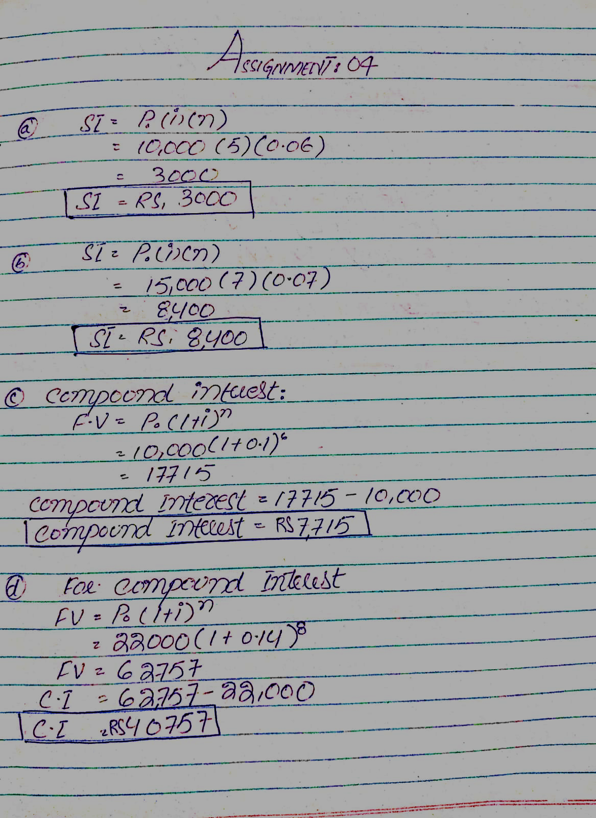

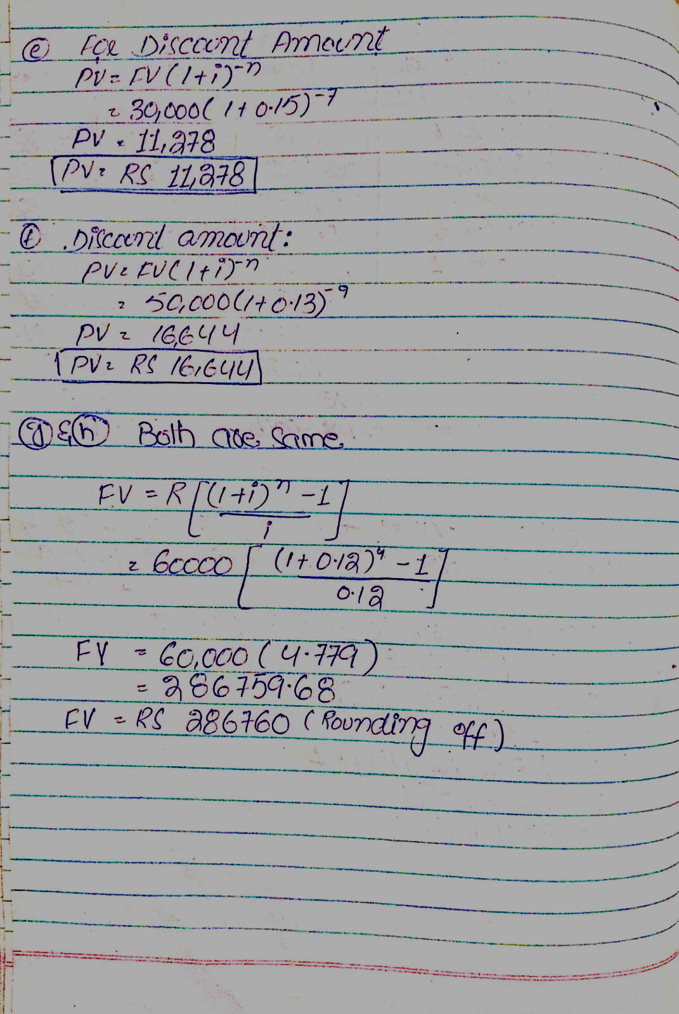

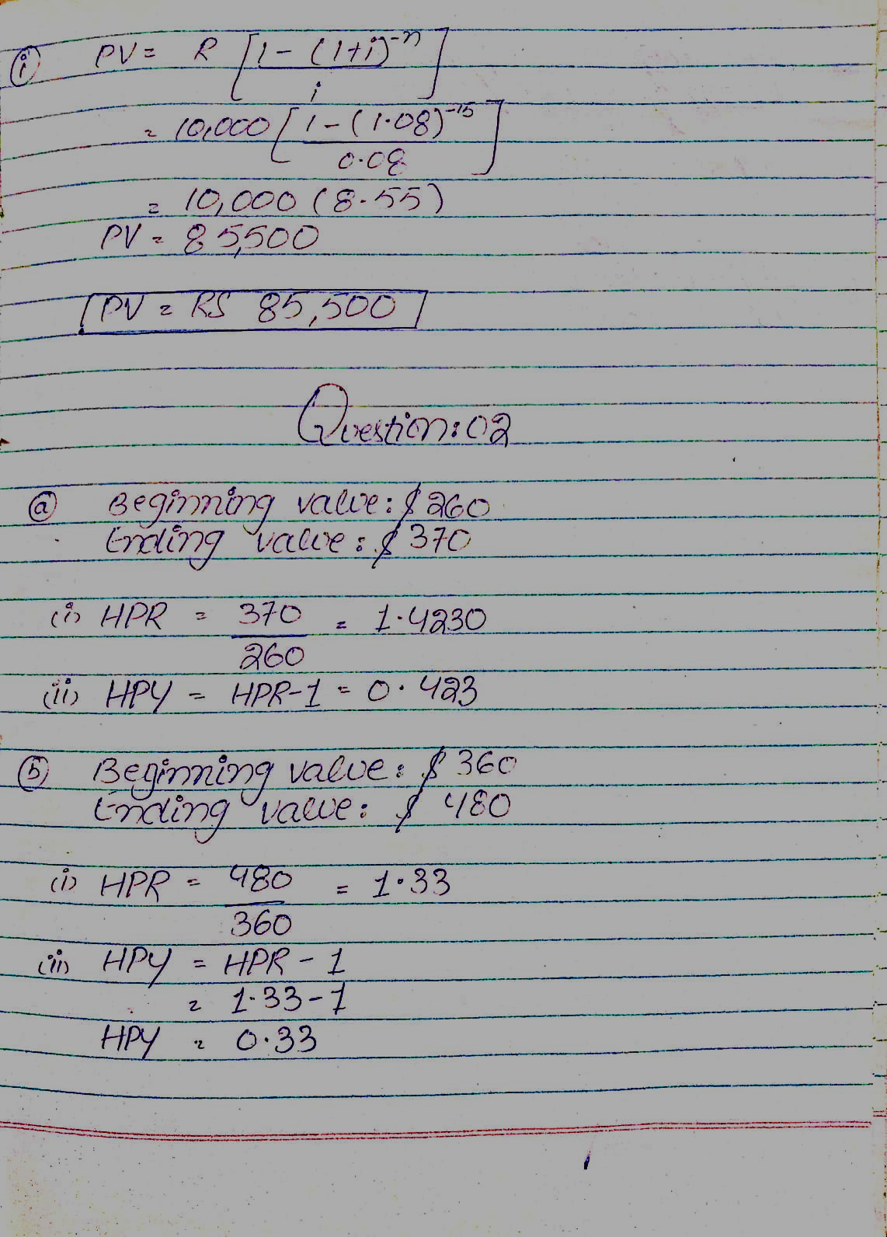

Q. 2 **(Measures of Historical Rates of Return),**

1. If Beginning Value of Investment is $ 260 and Ending Value of Investment is $ 370
2. If Beginning Value of Investment is $ 360 and Ending Value of Investment is $ 480
3. If Beginning Value of Investment is $ 220 and Ending Value of Investment is $ 290

**Calculate:**

(i) (HPR) (ii) HPY

Soultion **(a)** (i) HPR = Ending Value of Investment = 370 = 1.423076

Beginning value of investment 260

(ii) HPY = HPR – 1 = 1.4230 – 1 = 0.4230 OR 42.30%



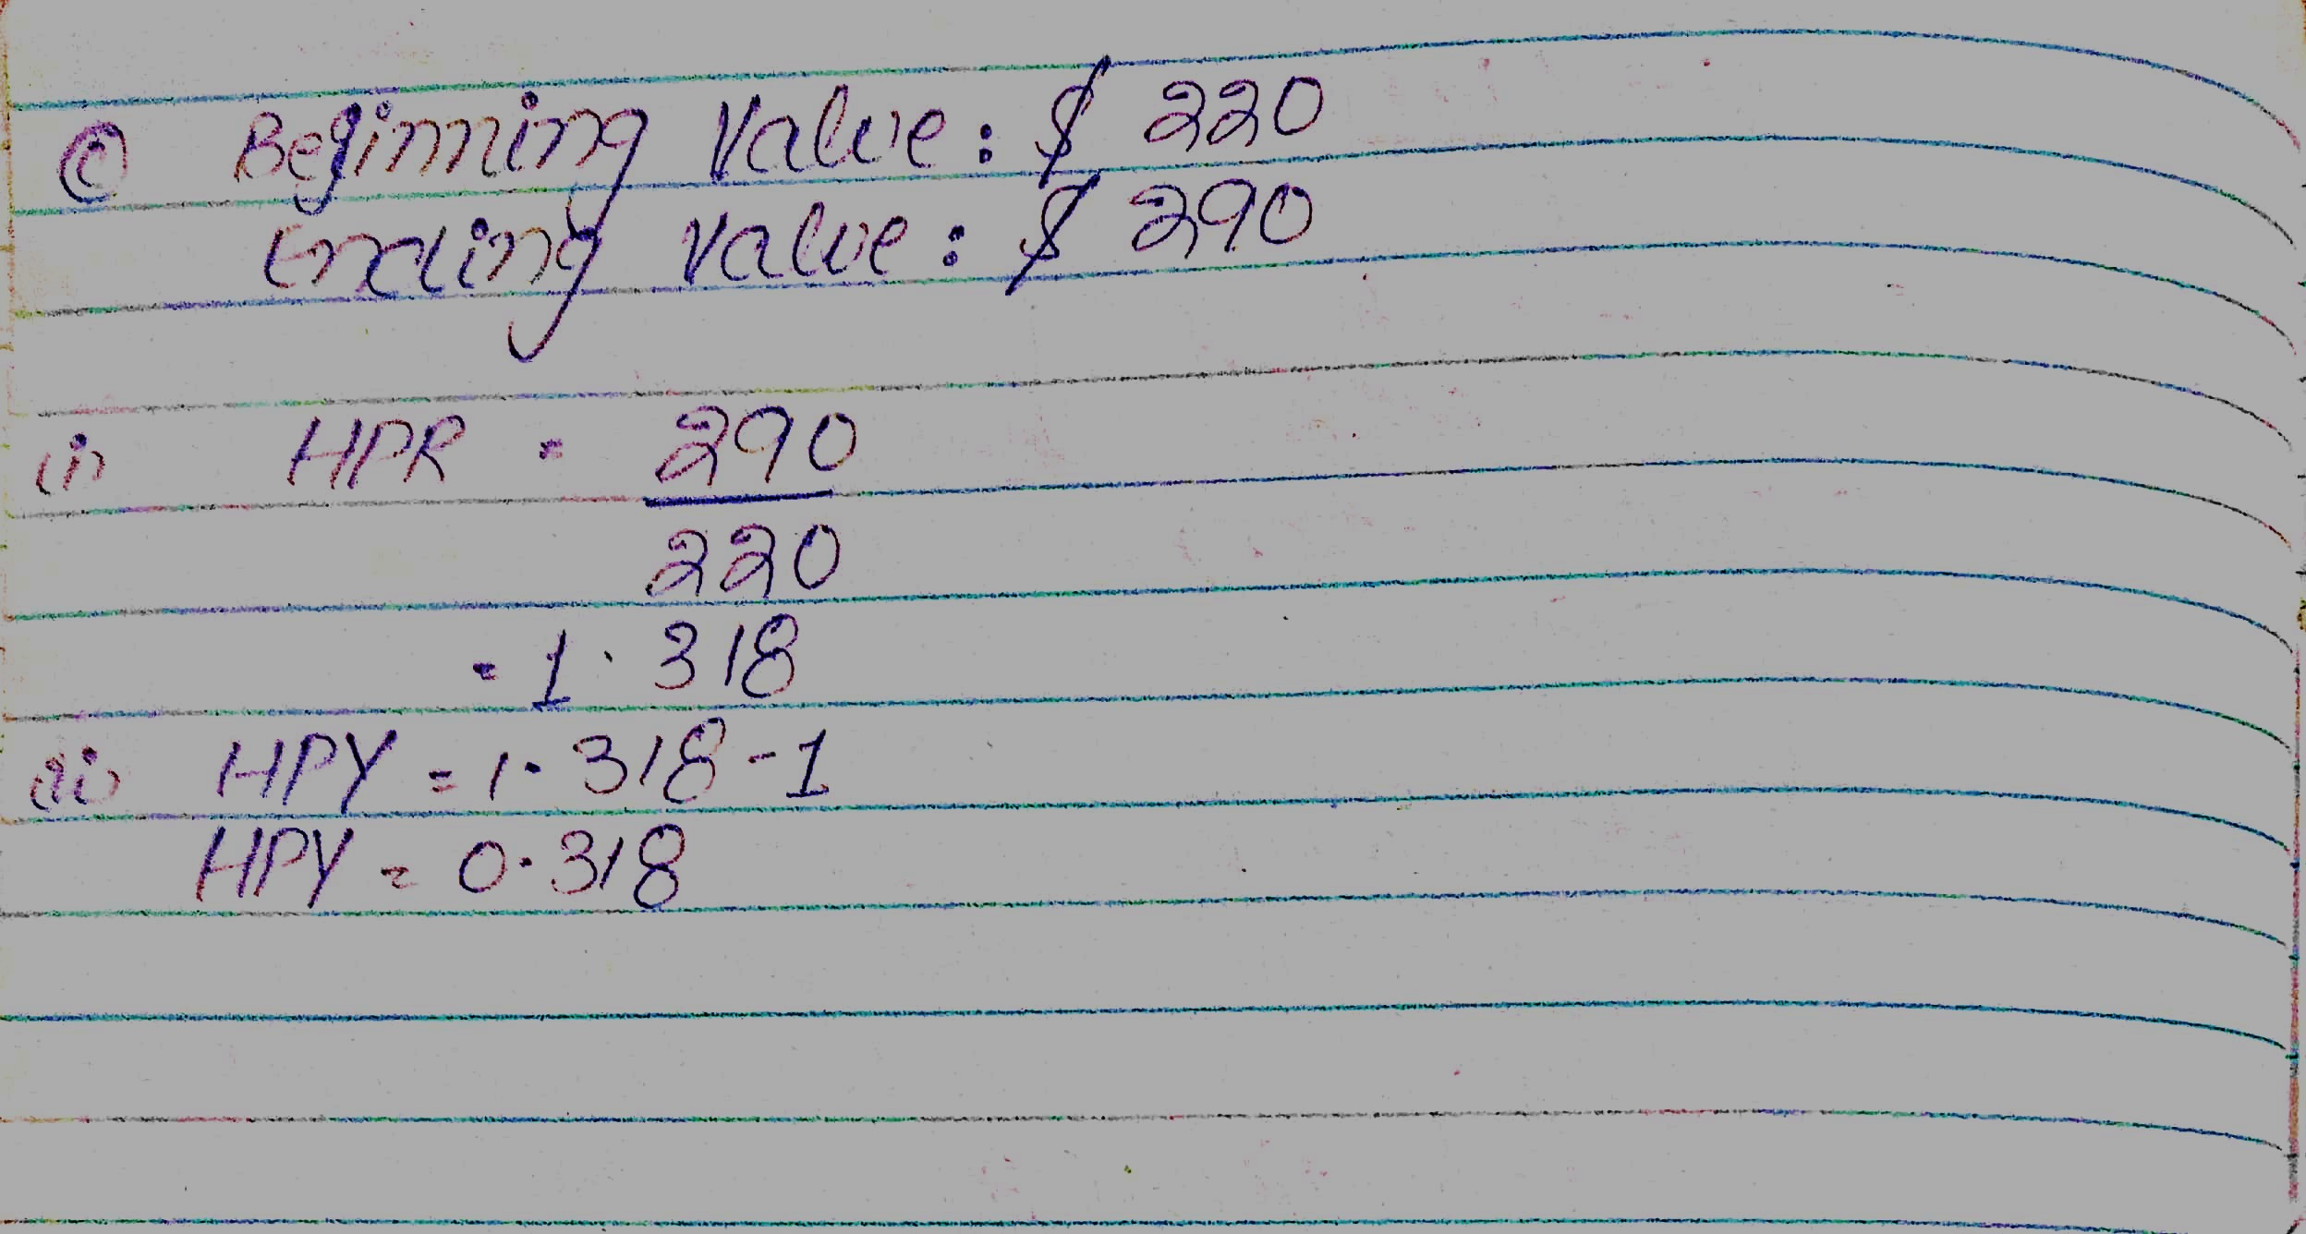

**Q. 3 Capital Budgeting**

|  |  |  |  |  |
| --- | --- | --- | --- | --- |
| **YEAR** | **CASH FLOW** | **(8% PVF)** |  |  |
| 0 | Rs. (20,00,000) |  |  |  |
| 1 | Rs. 450,000 |  |  |  |
| 2 | Rs. 300,000 |  |  |  |
| 3 | Rs. 350,000 |  |  |  |
| 4 | Rs. 550,000 |  |  |  |
| 5 | Rs. 600,000 |  |  |  |
| 6 | Rs. 200,000 |  |  |  |

**Calculate**

1. NPV (Net Present Value)
2. Payback Period
3. Profitability Index (PI)
4. IRR (Internal Rate of Return)

